Name: Laiba Asim
Sap id: 65230

Lab 12

Example Code:
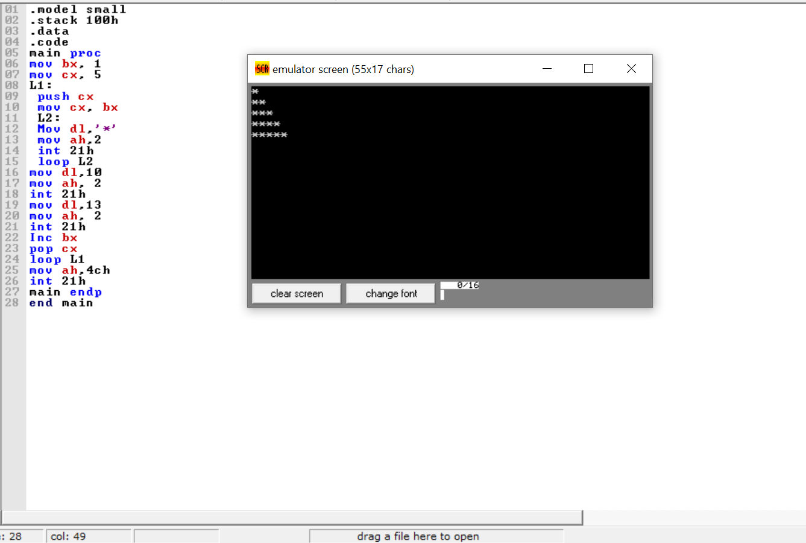

Task 1:
Write an assembly program to print the following output using nested loops. (03) 3. Write an assembly language program to print the following output using nested loops. (05)
*****
****
***
**
*
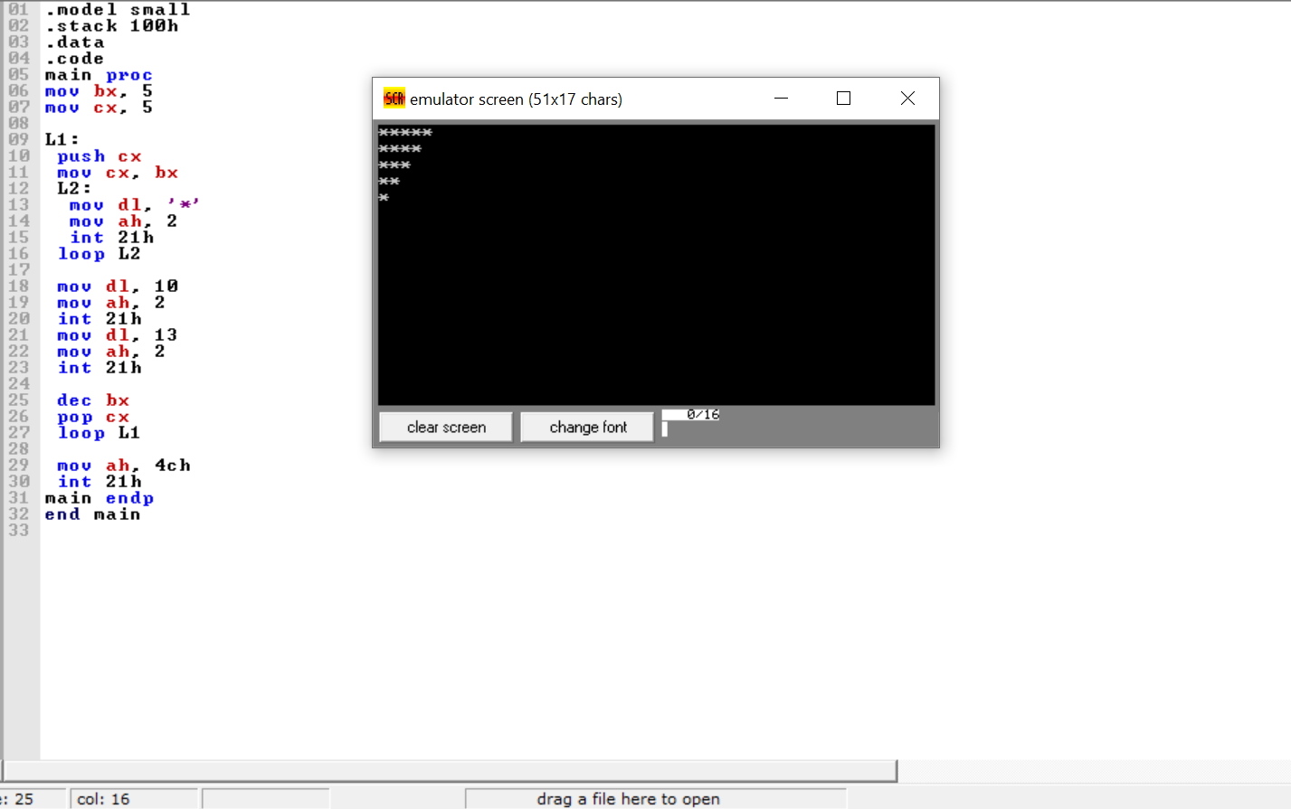

Task 2:
Write an assembly language program to print the following output using nested loops.
1
12
123
1234
12345
